**Use Case Diagrams , Sequence Diagrams and Risk Register**

**Transit Payment System :**

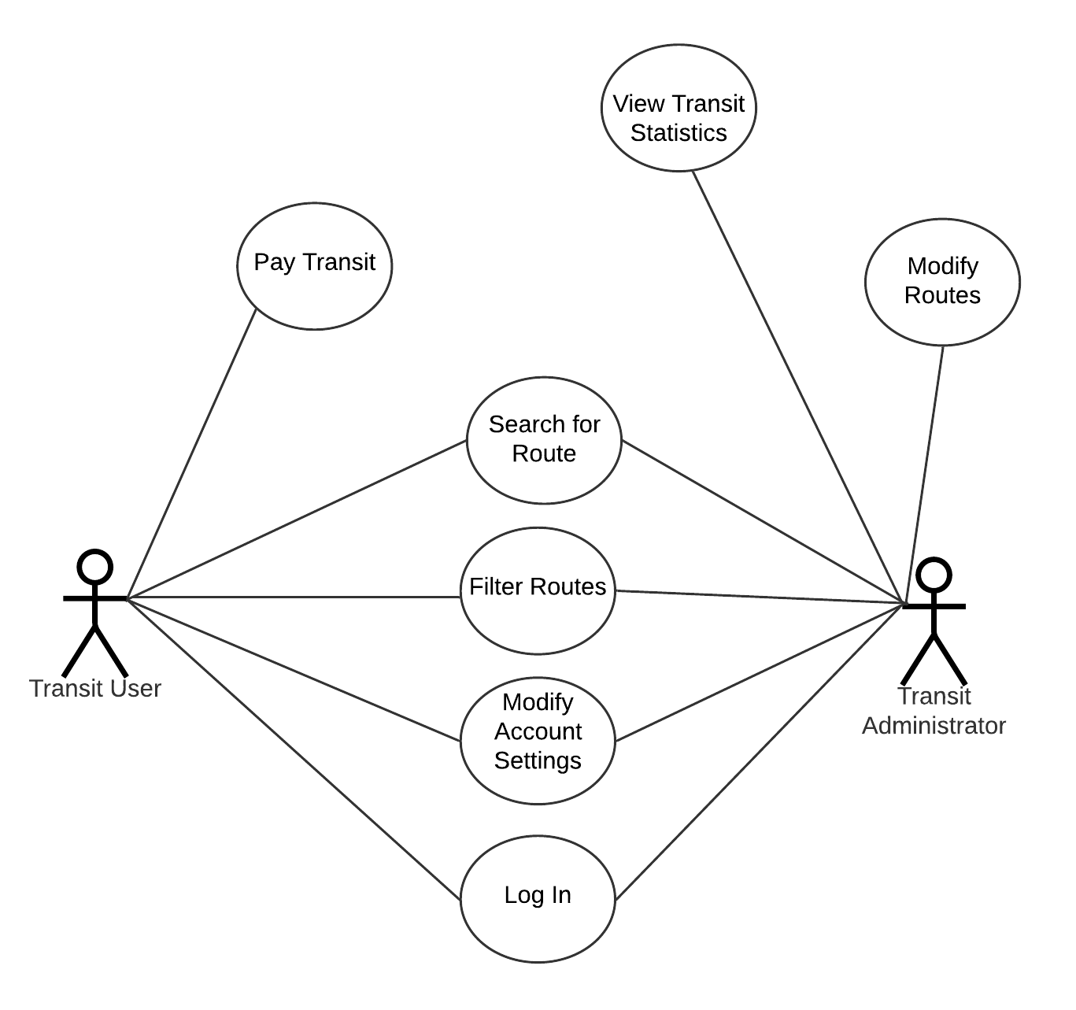

**Iteration#1 :**

* Registration Use Case

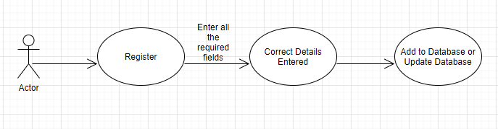

* Login Use Case

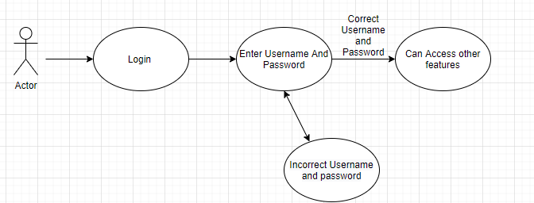

**Iteration#2 :**

* Search for routes

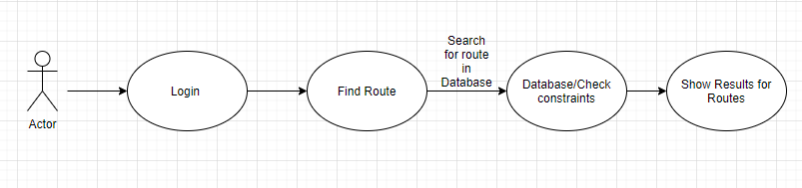

* Transit Schedule

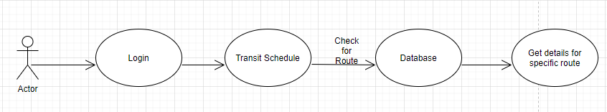

**Sequence Diagram**

**Iteration#2 :**

* Search for route :

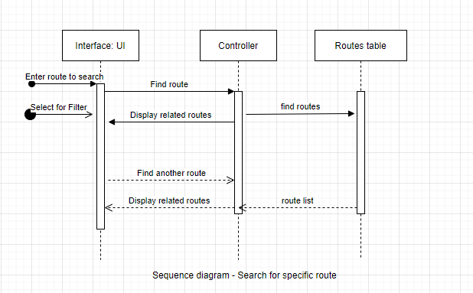

* Transit Schedule :

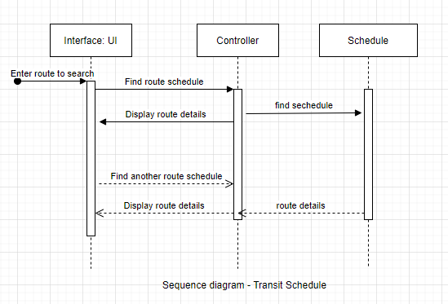

**Risk Register**

|  |  |  |  |  |  |  |
| --- | --- | --- | --- | --- | --- | --- |
| **S.No** | **Risk description** | **Likelihood(%)** | **Severity(%)** | **Risk Exposure(hrs)** | **RMMM** | **Assigned To** |
| **1.** | Constraints might not be handled properly and Exceptions will appear from constraints | 60% | Medium 40% | 4 |  | Heena |
| **2.** | Illegal users may be able to enter the system | 60% | High 60% | 6 |  | Heena |
| **3.** | Larger number of users will lead to system crash. | 50% | Medium 40% | 3 |  | Heena |
| **4.** | End users resist the system and would not like the whole UI | 40% | Low 20% | 2 |  | Heena |
| **5.** | Technology will not meet the expectations | 20% | Low 20% | 2 |  | Heena |
| **6.** | Customer will change requirements | 50% | Medium 40% | 4 |  | Heena |